CHAIRMANS REPORT 2019

2019/20 has been another great year for the Newmarket play park. As with previous years we have seen some changes in the committee, Peter smith has now left the committee along with Innes Murray, their contributions will be greatly missed but we wish them well. Our committee now consists of 8 members of whom there are 6 directors and 2 non director committee members. We have had interest from two of our volunteers to join the committee and hope to make them a part of the team in the near future.

As always we have had a great response from volunteers and local businesses who support our fund raisers throughout the year which has been a huge benefit to the park. Without this support we would not be able to continue and we are very grateful for their time and contributions. The local businesses especially over the last year have been very generous donating time, resources and their products to our various events throughout the year. A special thanks goes out to Cal Max, Peels and Angus Mackays who have been a huge help with some of our bigger projects.

We started 2019 where we left off in 2018 by continuing some of the repair work in the toddler and child play area in January. This saw the replacement of the old foot boards in the little hamlet climbing frame along with the replacement of the bolts and caps.

On February the 4th we had our AGM which was held in the Laxdale hall and was well attended. The election of office bearers took place and our plans for the year ahead were put in motion. Office bearers were as follows, Murray Macleod – chair, Lewis Mackenzie – vice chair, Kenny Morrison – secretary and Innes Murray – Treasurer.

Following on from our AGM it was decided to meet with an officer from Third sector Hebrides just to make sure we were doing everything we should. We met with Hector from Third Sector on the 19th and discussed our accounts, constitution insurances and our charitable status. Hector advised us that everything was on track and he was happy with how things were being run.

We held our Bingo night on the 1st of March in the sea angling club with prizes donated by Harris distillery, Stornoway spares, Islebe, Arriba, The Good Food Boutique, Perfectly polished, The Sea Angling club, Caberfeidh, Surf Hebrides, Kristy’s dance studio, The Crown, Ishga, H.I.C, Adventure island, Auto parts, Hebridean bouncy castle, Lighting and Electrical, Melbost farm amongst others. The night was a fantastic success and raised over £1000 for the park.

The 16th of March 2019 saw our first community maintenance day in the park where volunteers did some general tidying and maintenance to start off the year. A community skip was provided for general waste for the wider community. There was a fantastic turnout and some great work was done to kick off the year. We did some major drainage work and removed the old Springer from the toddler/child play area. These days have become an important part of our calendar, improving community relations and getting the wider community involved. Following on from this we started the installation of the new Springer and repair of some of the timber trail stepping logs. This was completed by the end of March
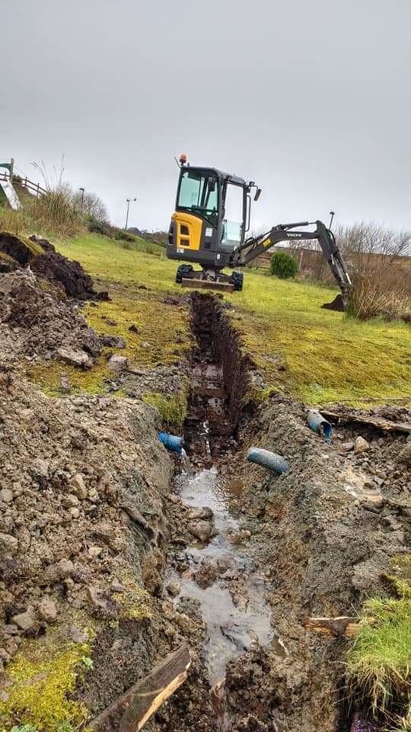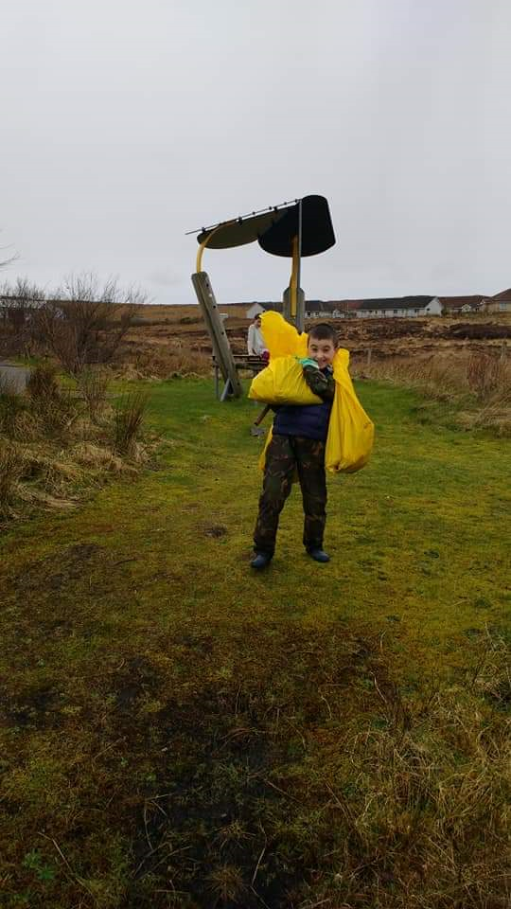

April saw the start of our grounds keeping season, this year the park has been maintained by John O Conner grounds maintenance on a fortnightly basis. They have also taken on our monthly inspections of the park which has gone very well. Along with this we have also involved the community service led by John Davidson to do our fortnightly bin collections, this is done as and when they are available so we still run our own rota to fill any gaps where they cannot manage. This has also been a success.

Also in April we took delivery of our new play park equipment purchased with funding from Point and Sandwick wind turbines and the landfill trust. Following on from our drainage works in March, we planted a grove of trees in one of the newly drained areas, included in these trees were two donated to us by Angus McNeil as part of the Queens Commonwealth canopy.

As part of our continuing links with the community we were pleased to see the 1st Laxdale cubs doing their nature badge in the park on the 25th April. They had a fantastic evening search through the flora and fauna of the area.
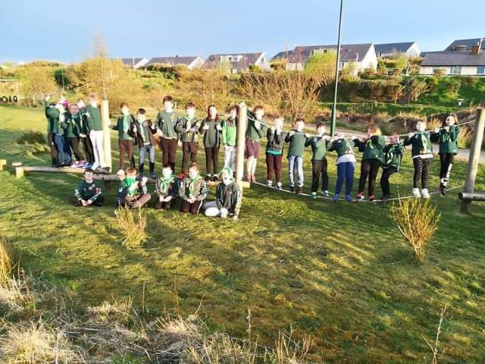

The beginning of May saw the start of the installation of new play park equipment by Angus MacKay’s. This includes a new shelter, an inclusive swing and a climber.
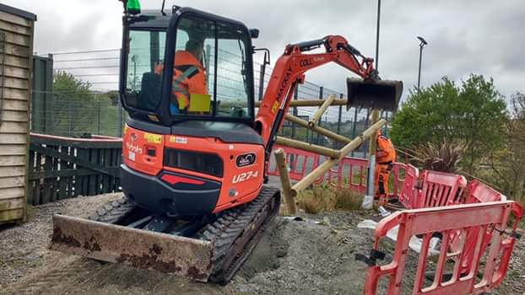
On the 11th of May we had our first fun day fundraiser of the year in the park, it was a fantastic fun day, As always we had our usual bouncy castles, bbq with food donated by W.J. MacDonald’s, candy floss, toy stalls, raffle, local baking, ice creams, balloons, and of course the park itself for folk to enjoy. We also had a visit from the local ambulance who let the kids take turns of sitting in and turning on the sirens and lights, a big thank you to them. There was a fantastic turnout by volunteers and supporters alike raising a fantastic £1300 towards the play park funds.
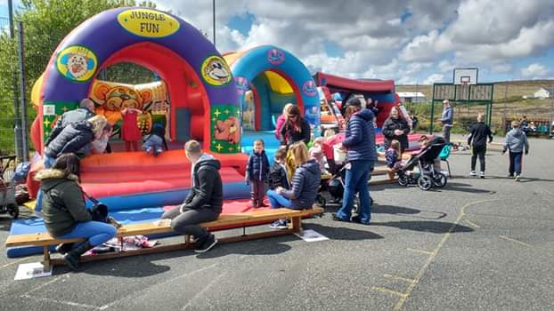

June saw the work continuing on our new equipment installation by Angus MacKay’s and a new bench sited in the toddler/child play area donated by local Catherine Macritchie. Also in June and again as part of our community links, we supported Laxdale School on their fun day by supplying and erecting our marquee and doing candyfloss for them on the day which helped in raising money toward their school funds.

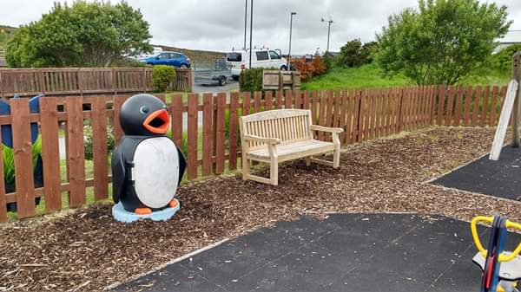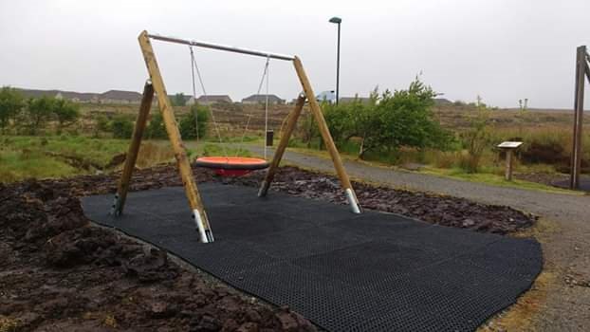

Following on from this and on completion of our new equipment, we had a visit from the Mrs Macleod (head teacher) and Mrs Rigg (deputy head) along with the pupil council from Laxdale school who got to see their newly installed painted wood slices and also tested out the new equipment. It was great having them and they loved the work that’s been done. Also at the end of June and from slightly further afield we had a visit from Leverburgh School who had travelled up for their end of year school trip.
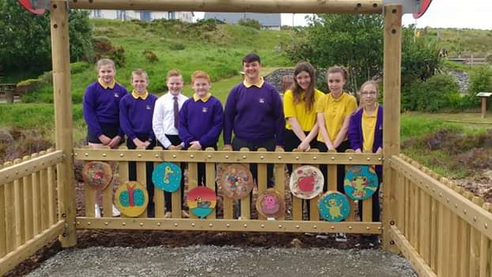
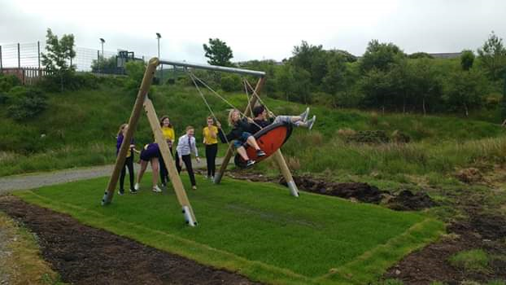

We had a lovely surprise this June when we found an area that had been sown with wild flowers 2 years ago by the Lewis Christian School burst into flower and gave us a fantastic display through June and July.
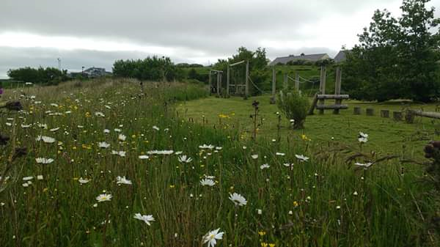
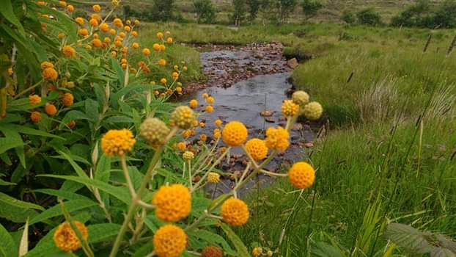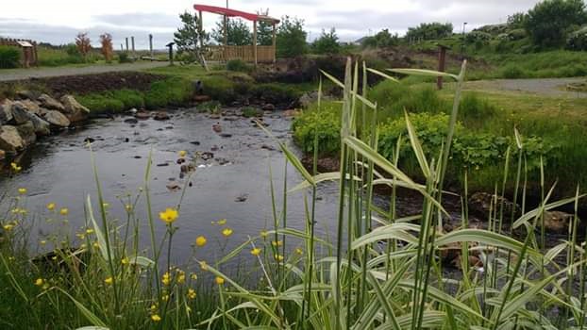

As part of our links with other organisations, in July we supported the RNLI Stornoway in their open day for the third consecutive year. It is fantastic to be involved with such a worthy cause and hope to continue this relationship.

For the second year in August some of the committee, along with local volunteers Mary, Gabrielle, Anne and Annette, went along to the local carnival day with a stall selling burgers, hot dogs, candyfloss and milkshakes. It was a fantastic day and raised over £1000 for our funds. We are hoping this will become a regular fixture in our calendar as it was so successful again.
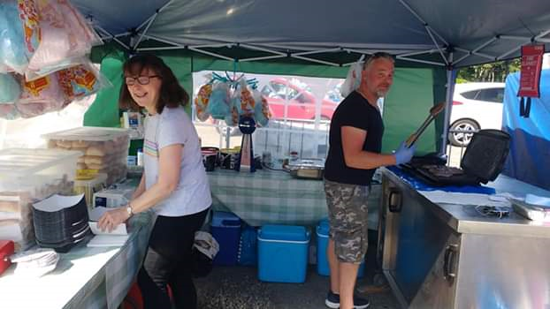

September saw our second community cleanup day in the park which again was well attended and saw some general maintenance and clearing done, lots of painting and this year some bulb planting, and more tree planting as well as the final repairs on the timber trail completed. Also September saw this year’s ROSPA inspection being carried out.
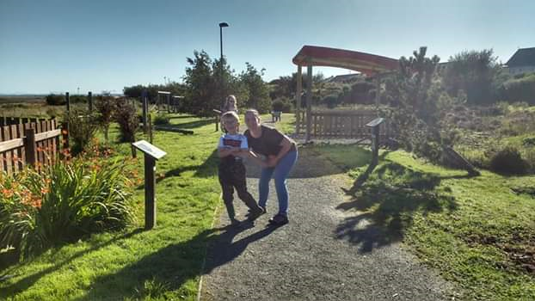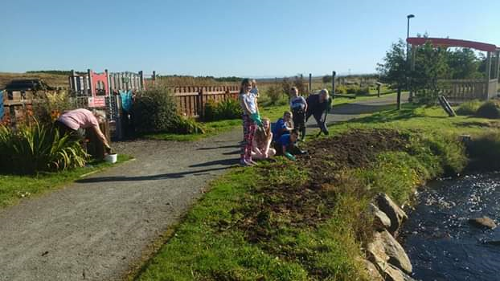

Last year as the profile of the park continued to grow we decided it was time to have our own website which we set up in October. The hope was to inform people of our purpose and goals and keep them up to date and informed of our progress. This year we added Membership forms to the site which as of yet there has been no uptake but hopefully as it becomes more established this will pick up. www.newmarketplaypark.com

In October we held our annual community Halloween/fireworks evening, this has become one of our regular events and although it does not raise a huge amount in funds it has become very popular in the community and is great fun to host. This year we had pumpkin carving competitions for the children, we also had a family fancy dress competition with a grand prize of a family dinner in the Crown Inn. This proved very popular and we had some great entries from which the winner was chosen by a Facebook vote.
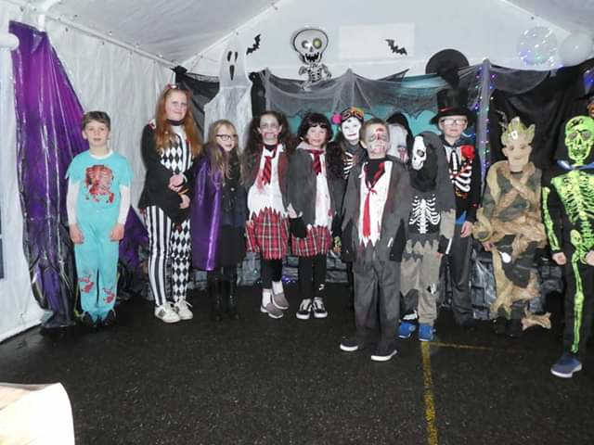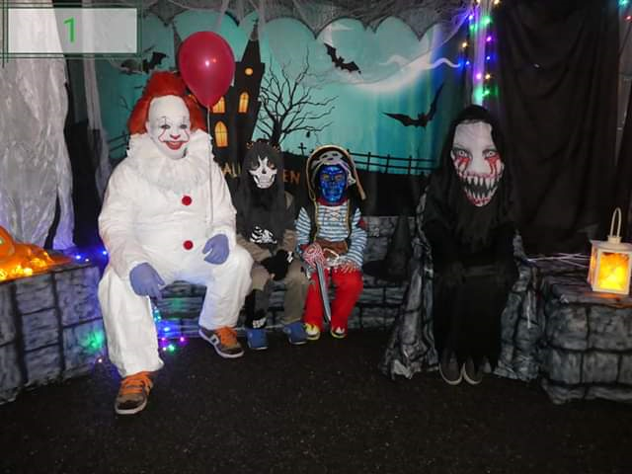

In November we had our bag packing day in the co-op from 10am to 6pm which raised £800 towards park funds.

As with previous years we have continued to have a great relationship with the local school and hope to continue building on this. Laxdale School has been a great supporter of the play park and has been a great help throughout the year posting our events in their newsletters and promoting the park. Also we have great links with the local cubs/beavers pack, who I’m told are still enjoying camping with the tents we donated. As we have said in previous years, we would not be able to continue without the support from our local community, businesses and councillors. They have been a great support throughout and we are very grateful to them all.

Finally, with a new year ahead of us we are hoping to continue to build on the success of previous years. We hope to move further forward with the community path and finally complete it connecting the Tong and Newmarket communities in the near future and have further plans for improvements in the park including the possibility of an eco friendly composting toilet. 2019 has been a fantastic year for us and we are looking forward to the future.

